**ONLINE CLOTH MART-VYNTRAMART**

**1. INTRODUCTION**

The online cloth mart web application is intended to provide complete solutions for customers through a single get way using the internet. It will enable customers to browse through the shop and purchase them online without having to visit the shop physically. The administration module will enable a system administrator to approve and reject requests for new queries to shop category. Customers can browse for range of products and services. Online cloth mart enables customers to use search features to find specific models, brands or items. Online customers must have access to internet and a valid method of payment in order to complete a transaction through credit card or debit card or Paypal service. The invoice statement will be sent to the customer once the transaction completed.

**2. SCOPE**

This application allows customer to maintain their cart to add or remove the product over the internet.

**3. Overview**

This online cloth mart system provides an easy solution for customers to buy the product without going to the shop. The proposed system can be used by any users and it doesn’t require any educational level, experience or technical expertise in computer filed. It requires knowledge of how to operate a computer.

**3.1. DESCRIPTION**

**This system has the following product functions,**

* User Management
* Category Management
* Items Management
* Order Management
* Shipment Management
* Invoice management

**3.1.1 User Characteristics**

User should be familiar with the terms login, register and order etc.,

**3.1.2 Actors**

This system has 2 principal actors Administrator and Customer.

**3.2. FUNCTIONAL REQUIREMENTS**

**1. Registration**

If customer wants to buy the product then he/she must be registered.

**2. Login**

Customer logins to the system by entering valid user id and password for the shopping

**3. Changes to Cart**

Changes to cart means the customer after login or registration cn make order or cancel order of the product from the shopping cart.

**4. Payment**

In this system the mode of payment designed by using Paypal service.

**5. Logout**

After ordering or surfing for product, customer has to logout.

**6. Invoice Generation**

After ordering for the product, the system will send one copy of the bill to the customer’s Email-address and another one for the system database.

**3.3. NON FUNCTIONAL REQUIREMENTS**

1. Scalability
2. Maintainability
3. Usability
4. Availability
5. Security
6. Reliability
7. Reusability

**3.4 Design Models**

**3.4.1 Use Case Diagram**

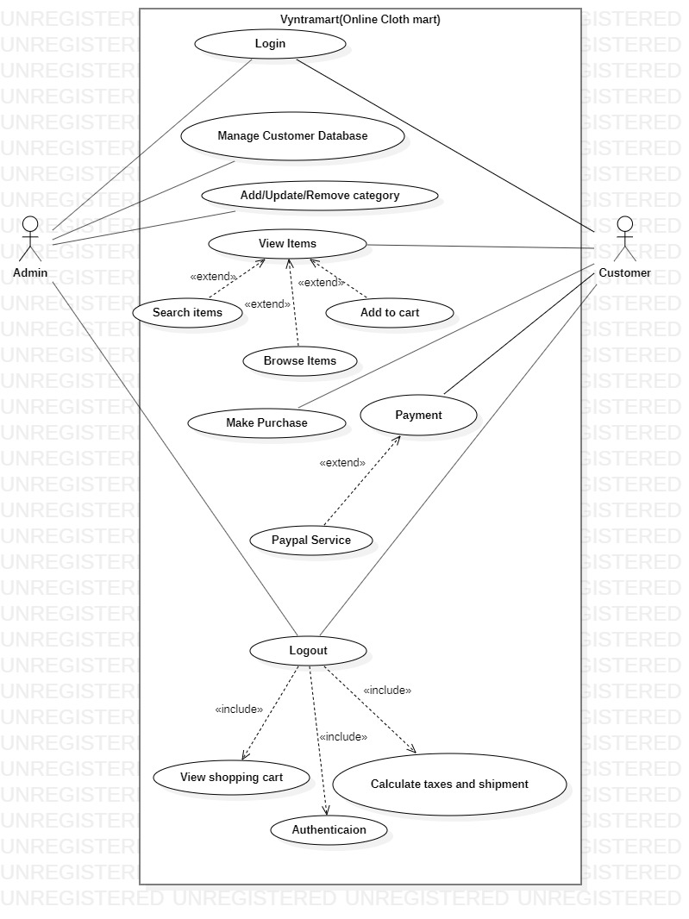

**3.4.2 Class Diagram**

